**siddharth krishnan**

NEA

# Table of Contents

Table of Contents 2

Analysis 3

Problem Statement / 4

Problem Background/ 5

Target Demographic/ 6

Limitations/ 7

Research: Case Studies/ 7

Case Study 1: Doodle Cricket 7

Case Study 2: Real Cricket 24 8

Case Study 3: Cricket 24 9

Research: Questionnaire/ 10

Mathematics (Got from ChatGPT) 13

Data Flow Diagram of an Existing System 14

Data Flow Diagram 15

UI Ideas/ 15

Core Objectives/ 16

Extension Objectives/ 23

Entity Relationship Diagram/ 24

Data Volume/ 24

Data Source and Destination 25

Potential Solutions 25

Chosen Solution 25

Design 26

# Analysis

## Problem Statement /

**The Problem**

One of the most popular sports in the world is cricket which is played by millions across the world. However, cricket is a very complex game for people to understand which is why it is not the most popular sport in the world. This means the target audience of the sport is already narrowed down to the big fans of cricket. This is normally solved by elders teaching children to play from a young age and the sport spreads its popularity from there. However, this is a slow and outdated method of learning the sport because it is difficult to get into cricket if there is no one to teach you the rules of it. If you have not learnt it from a young age, then you are unlikely to become interested. Even the video games created based on cricket are complex and there are too many controls which can confuse casual players or new beginners. This makes for a more overwhelming experience and causes loss of interest in the user. There are no widely available cricket games that are simplistic and functional in creating excitement in the game instead there are only games targeted at existing fans. Many of the cricket games are very high performance, therefore it requires expensive hardware to run it smoothly. In AAA games, there are lots of busy interfaces and heavy advertising that occurs which can put people off. This creates cluttered screens because of lack of simplicity. Not everyone has access to expensive hardware but almost everyone across the world has a smartphone. As more young people use technology, there is a clear gap in the market for a simple and undemanding cricket game that can teach people the basics of the sport. This can be used to help people engage and interact with cricket which can spark an interest. As cricket is seen as a time-consuming sport, many people are put off by it which eliminates a whole demographic who could enjoy the game and just don’t have time for it.

**The Solution**

My aim for this project is to create a game where users can play cricket, removing the confusing aspects of the game whilst still making it fun The game will have basic controls, such as a single button to hit the ball, making sure the experience is easy and seamless for any player to learn. This will also allow the user to run the game on many types of computers, as it will not be a demanding game. The cricket game should introduce cricket to a new player and teach them the rules of the game. For example, concepts like overs, wickets and the scoring system. It should also give users a competitive experience where they can compete against each other in a multiplayer format. To combat the time-consuming aspect of the game, it will have quick matches while still having the core features of cricket. Overall, the aim of this project is to get new people engaging in cricket and hopefully expand the fan base of the game while also providing an entertaining experience for the existing one.

## Problem Background/

Cricket is a sport played with a bat, ball, and two wickets either side of the pitch surrounded by a boundary as shown below. It consists of two teams of eleven players each. It is popular in countries like India, England, Australia, Pakistan, Bangladesh, Sri Lanka and many others. The objective of the game is to score more runs than the opposing team. 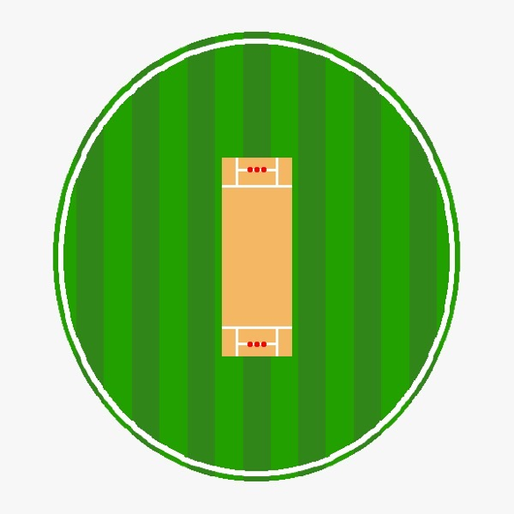

**The Rules:**

* A match is divided into innings (one or two depending on the type of game played) where one team bats and the other team bowls and fields. After the batting team is finished, they switch.
* The bowler bowls the ball at you, and you must try and make sure it does not hit the wickets.
* You are out if:
  + The bowler bowls the ball, and it hits the wickets.
  + The ball is caught by a fielder after the batsman hits it (before touching the ground).
  + If the batter fails to reach the other side of the wickets before a fielder hits the wickets
  + If the batters body blocks the ball that would have hit the wickets when the bowler has bowled a ball.
  + If the batter leaves the wicket area and the wicketkeeper (person behind the wicket) hits the wickets with the ball. This is called a stumping
* A run is scored when:
  + Two batters run between the two wickets after hitting the ball. The fielding team must chase the ball and throw it at one of the wickets.
  + Hitting the ball to the boundary scores four runs if it touches the ground inside the boundary.
  + Six runs if it clears the boundary without touching the ground.
* An over consists of 6 legal deliveries (balls). Bowlers take turns bowling overs.
* The team that scores more runs wins.
  + If both teams score the same number, the match is a tie (or draw, depending on format).
* On the wicket, there are lines showing where the bowler can bowl within. If the bowler fails to bowl inside those lines, the ball is called a wide. The batting team gets one run, and the bowler must bowl the ball again.

**The Problem:**

The main problem with this sport is the number of rules there are, and some are very unnecessary to understanding the very basics of the game. This is why in my game I am going to strip the game of its advanced and complex rules like runouts, no balls and free hits This will allow for a better user experience and allowing for new players to get interested into the sport. For example, features such as run outs or stumpings will not be in the game but running between the wickets and the core features like that will remain. Even removing the extra rules there are still many rules. To combat this, I will slowly introduce the rules to the new player. This will allow for a seamless learning experience for the user.

The game will be simplistic but one major difference to the doodle cricket game by google will be that I will have a bowling mechanic which allows the player to understand game situation and give the user a more versatile experience, allowing them to experience all aspects of the game instead of just batting. Instead of the complex buttons and controls in other cricket games, I will be taking inspiration from the google doodle cricket game where there is one button, and it is to swing the bat. As well as that the layout of the game might be similar due to the simplicity of the game design. However, I will be fixing a couple of issues with this including the amount of time taken between a bowl being bowled.

Another issue with these games is that they are not multiplayer, which defeats the purpose of two teams competing against each other. I am going to add a multiplayer compatibility which will allow for a sense of competitiveness. This will also increase interest for the game as more people will enjoy the human vs human gameplay more than human vs computer. The new players will also get a sense of how competitive this sport is.

## Target Demographic/

This project will mainly be focusing on people who don’t know how to play cricket and are new to the game. This means the age range is for anyone, but to appeal the younger audience 10-18, I will need to make it visually interesting to keep the user engaged. This means that I do not expect any of the users to have any experience in the game, as I will be introducing the game to the users. I will be adding a tutorial feature into the game to introduce the user into the game slowly. However, there are many complex rules so I will make sure to introduce them slowly to keep audience retention, especially for my target demographic of 10-18. Due to the age range of the audience, I will have easy to locate buttons as well as many helpful tips during the loading screens to keep the user entertained and interested. Colour and animations will aid the user’s attention to ensure quick understanding. The interface will use big colourful buttons, based on Fitts’s Law, which will improve usability for younger players. This will be a big focus however I am also focusing on the existing fans of cricket, so I will need to include all the statistics that the user can view to entertain the audience more familiar with cricket. I can also add a multiplayer mode for the more advanced users so they can compete against each other.

## Limitations/

One of the biggest problems to this project is that the more experienced players will not get the freedom to do the techniques they would like to do. For example, the bowling could be seen as limited as I am only going to include the ball travelling a good length, short length and full length. This is so that the new user does not get overwhelmed by the options.

However, later I could include a complex control system that will allow the user to experiment with the more advanced control and variations to the ball like off-cutters or leg-cutters. This will allow my target demographic to expand to almost any person in the world. Using this, I will be able to better achieve my goal of getting more people into the sport of cricket.

## Research: Case Studies/

### Case Study 1: Doodle Cricket

Google’s doodle cricket game is a free and simple cricket game where you control the batsman by hitting the ball with the yellow button when the ball comes near the bat. This is a very simple version of the game that is very engaging to a new audience as the cartoon style graphics help ease the cricket experience to the user. The basic controls make it accessible to a wide audience. This has timing included so if you time the ball badly, the ball could not hit the middle of the bat, or it could miss the bat completely getting you out. It has a high score feature which allows the user to compete with their high scores. This gives the game a competitive nature and it increases the audience retention. Since the graphics are so simple, virtually any computer can run it making it more accessible.

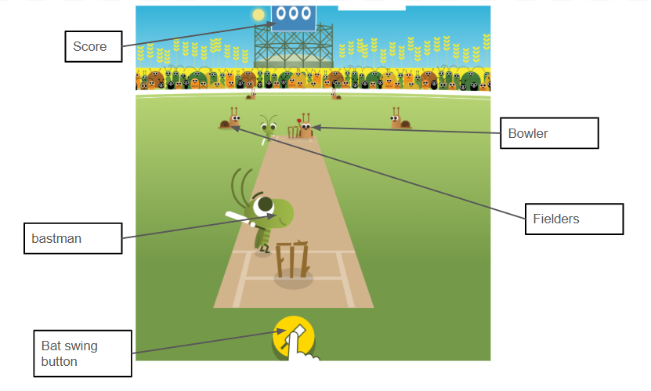

However, the lack of multiplayer or the ability to bowl makes the game less enjoyable as the players are only able to participate in one of the parts of cricket. This makes the game simpler but does not capture the full aspects of cricket. As well as that the game gets quite repetitive due to the simple throwing mechanics.

[google.com/logos/2017/cricket17/cricket17.html](https://www.google.com/logos/2017/cricket17/cricket17.html)

### Case Study 2: Real Cricket 24

Real cricket 24 is a very realistic and complex cricket game meant for the more advanced players. This is very intricate as you can bowl, bat and field. In this game, you can control whether you want to play the shot in the air or the ground and the direction. As well as the timing, you can move the batsman to better position yourself to hit the ball better. This game is very complex as the bowling mechanics feature spin bowlers, pace bowlers and you can decide the level of swing you would like the ball to have. You can decide where to place the fielders to make the game more interesting and it allows the users to create plans and develop game sense. The graphics are quite realistic, and the user interface is very complex and crowded. There is a mini map where you can see where the fielders are placed. There is also a scorecard at the bottom which can help the user track their score during the match. Since the graphics are mediocre, some phone will be able to run it however if the phone is not a newer model, then it might not be able to run.

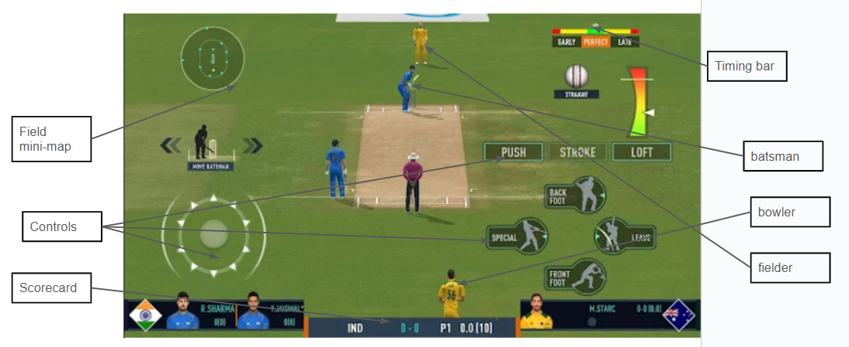

<https://play.google.com/store/apps/details?id=com.nautilus.realcricket>

Due to the complex nature of the game, this restricts the target audience to the people who understand cricket. This makes the game overwhelming to new players due to the crowded user interface. There is online multiplayer which adds a competitive nature to the game however, it is very complex to get set up which can make the user not want to play. As well as this, there are ads every over, and if you are doing a 50 over match, the user receives 50 ads in one match. This can be extremely frustrating to the user. The ball is coming quickly and that means that the user needs to react quickly and due to the number of controls, the user might not have enough time to react, and it can make it very frustrating to not be able to hit the ball.

### Case Study 3: Cricket 24

Cricket 24 is a very well-made easy to pick up cricket game. This game features batting bowling and fielding and they are very well made with the batting controlling every aspect of the batsman and the bowling being able to bowl in swing, out swing and different types of spin. This makes for a well-rounded game which increases audience retention. The controls are used by a controller or a keyboard and there is a multiplayer mode where the players can compete against each other. There is a field mini map where you can see where the fielders are placed. There is a timing bar where you can see how well you hit the ball or how well you bowled the ball. In the fielding there is a slider where if a ball comes at you, you need to move the slider to the ball to make sure you catch it. This makes the fielding experience more fun and enjoyable.

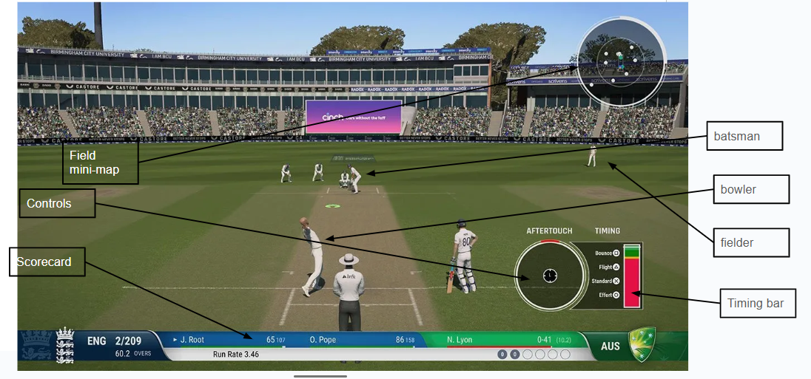However, this game is still very complex to a person who is not familiar with cricket games. There are a lot of controls you need to learn still making it quite overwhelming and the tutorial is very fast paced, which does not give you enough time to learn the controls properly. This means that the user can easily get overwhelmed and stop playing. As well as that the game is quite expensive making it even more difficult to get into good quality cricket games with no ads.

## Research: Questionnaire/

To find out more about the preferences and requirements of my cricket game, I created a questionnaire on cricket related questions. This has helped me figure out the general opinion about cricket which can help me better target the beginner audience. It also helps me understand the general needs of the user and helps the stakeholders give ideas on features they might want to see in the game. The link to the questionnaire is: [Cricket game Questionnaire](https://docs.google.com/forms/d/e/1FAIpQLSdyELXE2_uKWxhasBVyAGUBFtUaJiqs4bU7W8Gf43pkBRlGow/viewform?usp=sharing) . I asked people from a cricket club, so I have the views from enjoyers of the sport, and I have also asked year 12 students to get an idea of the general view. This will help target the people who are new to the sport.

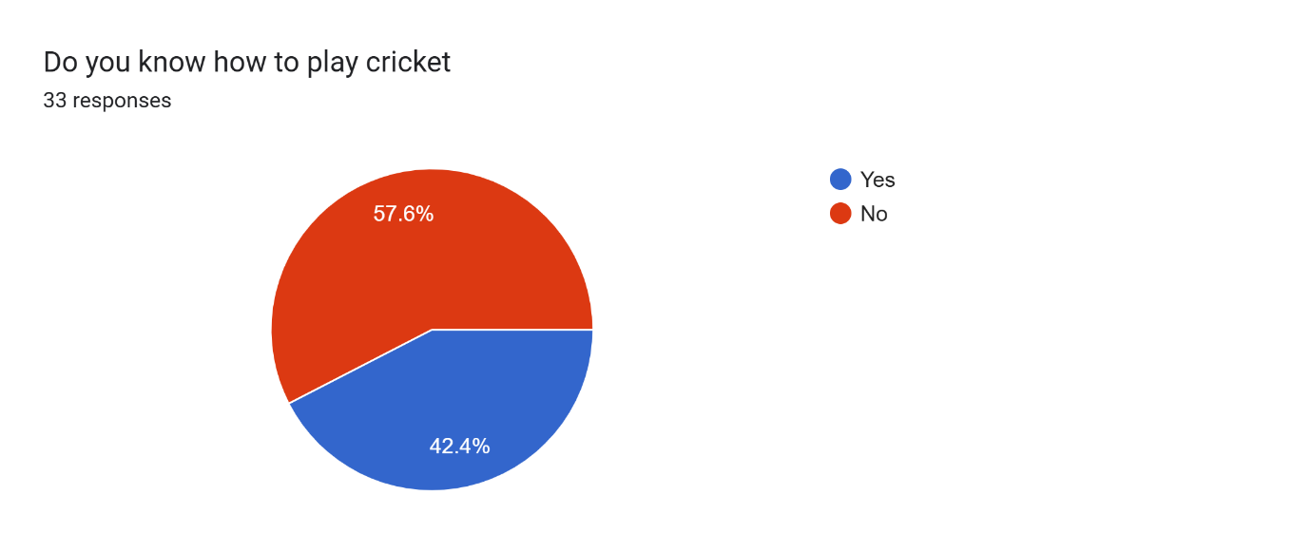Since 57.6% of people do not know how to play, I will introduce a tutorial like system that will slowly introduce the player the rules of the game. This has reinforced my idea that the average person has no idea how to play cricket, therefore I will be removing the complex rules as said previously.

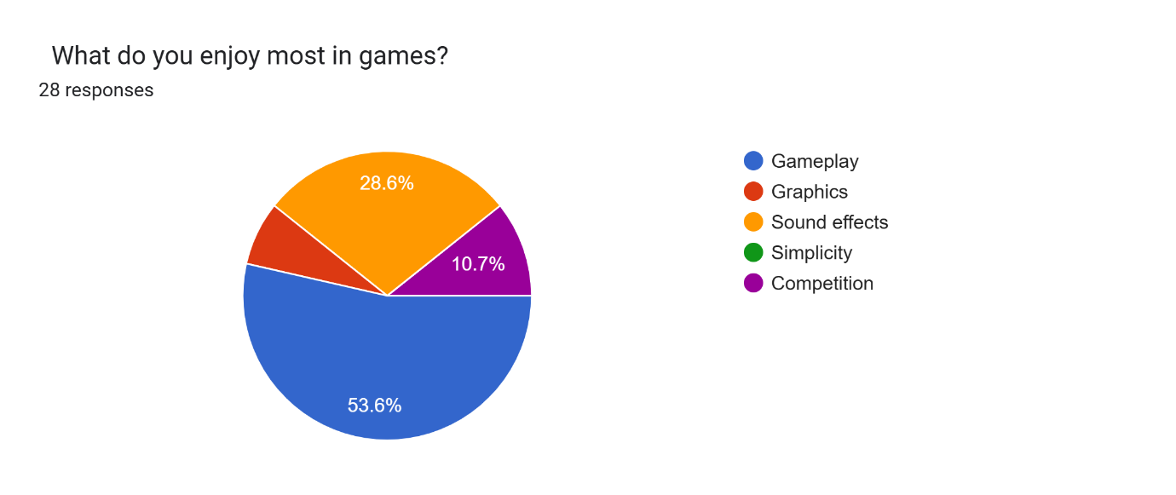53.6% of people enjoy gameplay, this will be the thing I focus on the most as it is considered the most important to my stakeholders. Competition will also be considered as 10.7% of people said they enjoy it the most. This means I can include multiplayer so players can play against each other. This means that I will not focus too much on graphics and fancy effects due to the overall feedback being focus on the core gameplay.

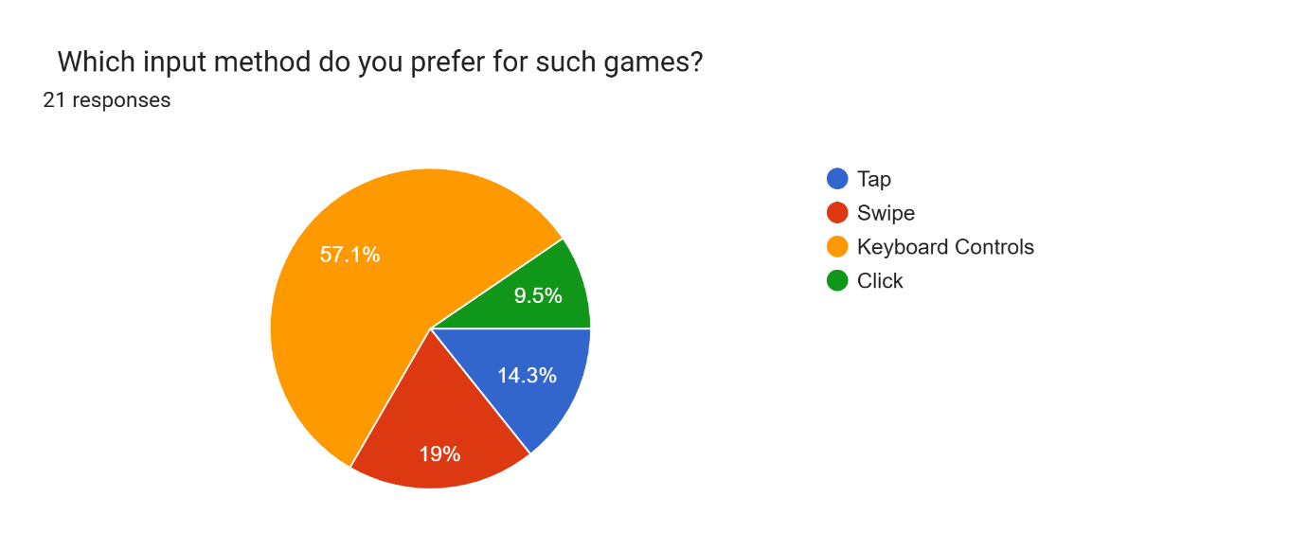There was a significant vote for keyboard controls with 57.1% but 19% asked for a swipe control method. Since swipe controls are very easy to use, the large demographic would like controls with easy-to-use controls. Therefore, to answer both majorities wishes, I will implement very easy keyboard controls which will encourage the new user to play the game and understand the controls. Moreover, the user will become fonder of the game.

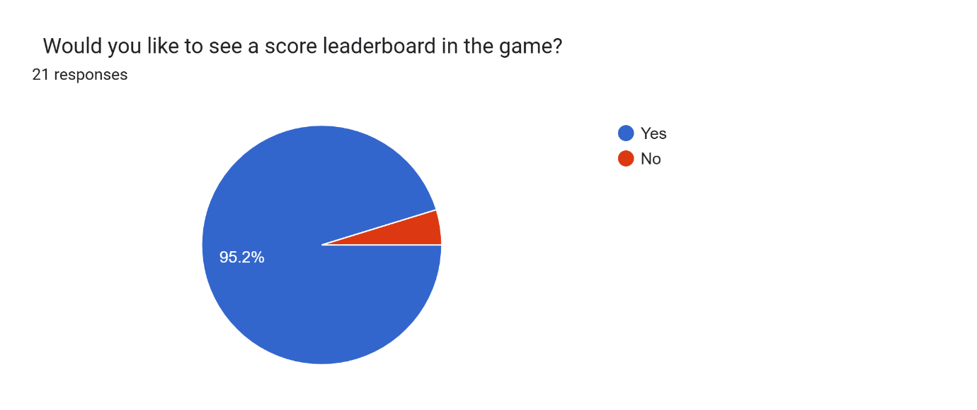I will add a leaderboard which will allow the user to see their score and compete with others to get a better score. This will help player retention and will also help with the competitive aspect of the game that the stakeholders asked for. As well as that, a leaderboard will allow for the user to track their individual scores.

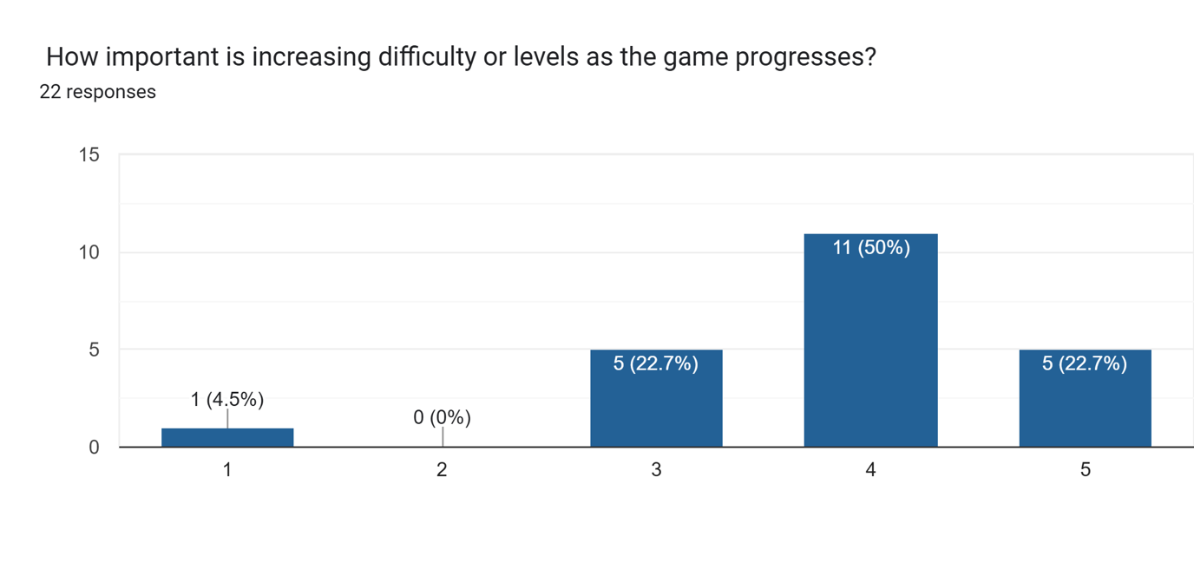I will make the game easy to learn for beginners and then once they have understood the basics, I can scale the game up in difficulty so that they do not get too bored. For the more experienced players, I can make the players play against similarly skilled players.

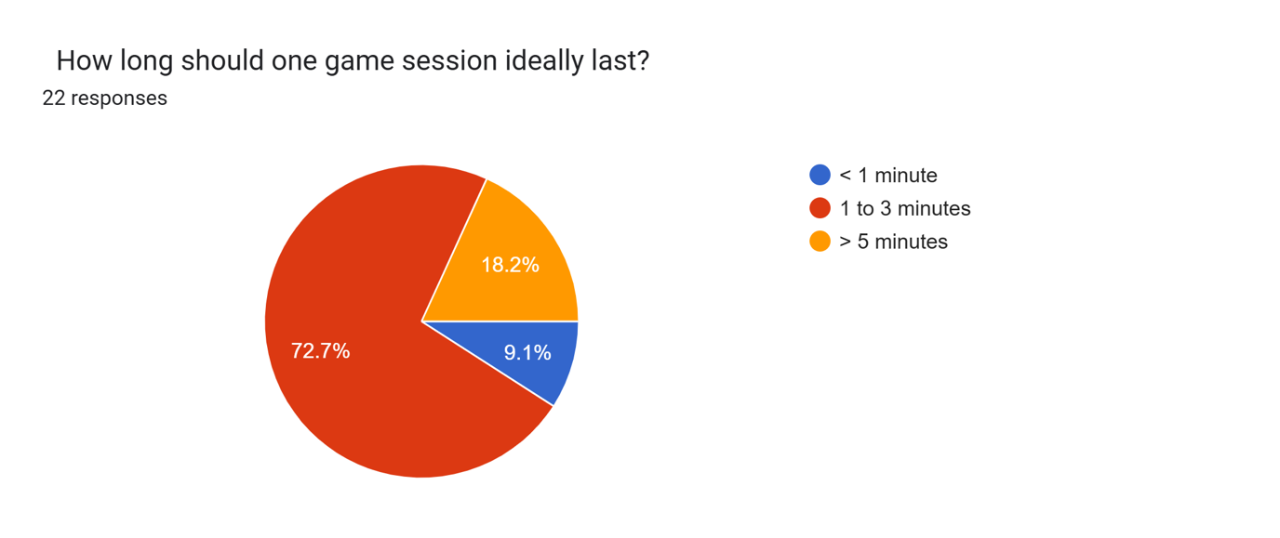

I will not make the game too long to match the busy schedule of students and people working a job. This means that as 72.7% of people said, I will make the game 1-3 minutes long.

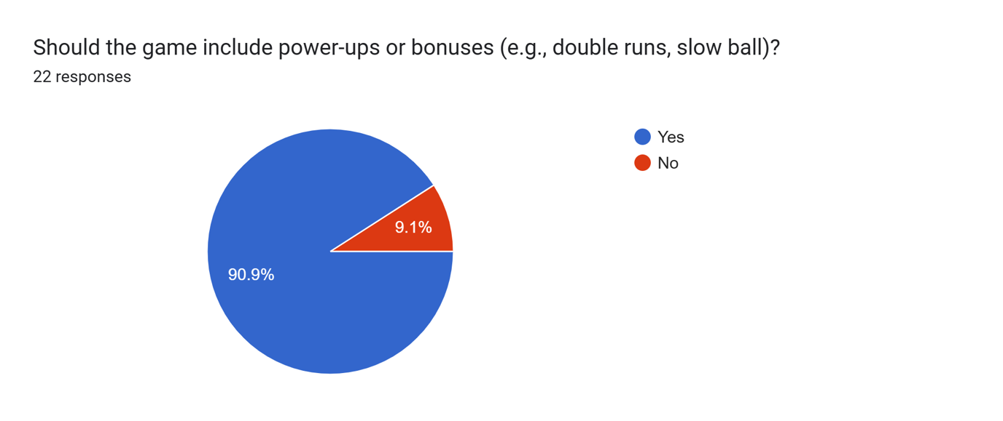

To make the game more enjoyable for beginners, I will add more fictional items into the game. This means that the average person can score more runs or defend more totals by these power ups. This can encourage the new player to continue playing the game if they are struggling.

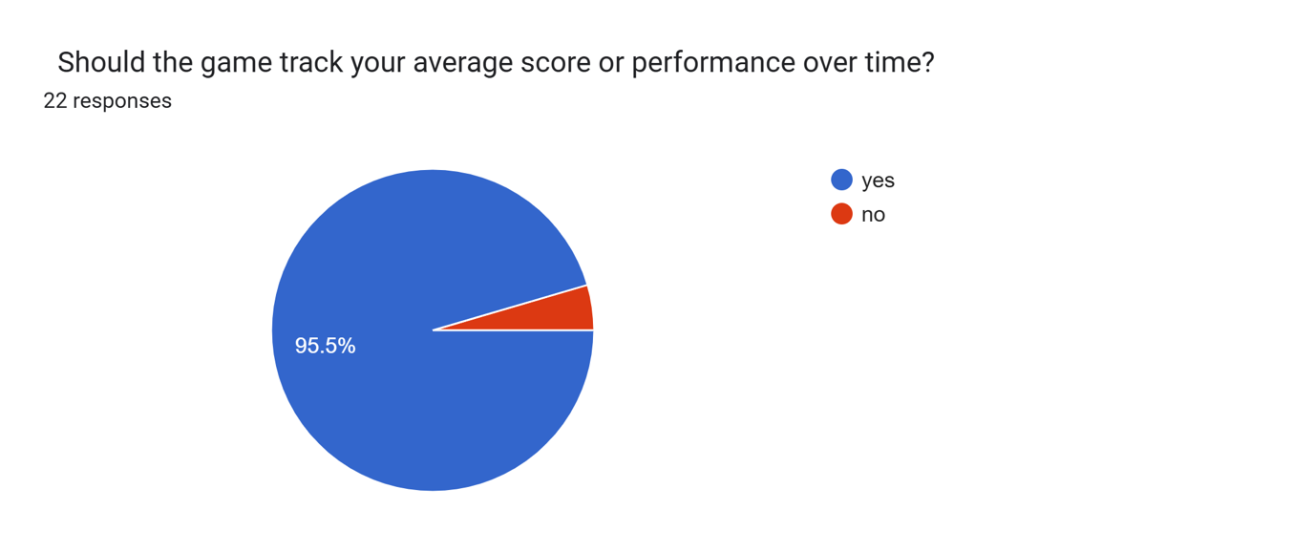

With 95.5% of people saying they want their progress tracked, I will add this feature in to make sure that the stakeholders can see their improvement. This can be an encouraging factor to get a beginner to keep playing.

**Conclusion**

In conclusion, this has helped me figure out the kind of game my stakeholders would like to have and the features they would like to have included. This will make the game more enjoyable and allow the user to get the most out of it.

## Mathematics/

|  |  |  |
| --- | --- | --- |
| **Concept / Effect** | **Equation(s)** | **Purpose in Bowling** |
| **SUVAT equations (parabolic motion)** | , | Models the vertical and horizontal displacement of the cricket ball under gravity. |
| **Launch angle** |  | Equation of trajectory → used to compute required angle to hit a specific target at distance. |
| **Velocity components (trig split)** | , | Separates velocity into horizontal and vertical components for ball launch. |
| **Coin toss** | 50% chance of heads or tails | Probability for the chance of heads or tails |
| Magnus effect (spin force) | F =k(ω×v) | Produces sideways drift of the ball when spinning (leg/off spin). |
| Swing effect | V = A x rand x accuracy | Adds lateral deviation for inswing/outswing based on bowler accuracy and randomness. |
| Randomised Speed |  | Ensures not every ball is identical, simulating bowler variation. |

|  |
| --- |
| **Key** |
| v = Initial velocity |
| Θ = Launch angle |
| g = gravity |
| t = time |

**Statistics**

* **Batting Average:** runs scored / dismissals
* **Strike Rate:** (runs / balls faced) × 100
* **Bowling Average:** runs conceded / wickets taken
* **Economy Rate:** runs conceded / overs bowled
* **Dot Ball Percentage:** Dot balls / Total Balls * 100

## Data Flow Diagram of an Existing System

## Data Flow Diagram

## UI Ideas/

Below are some ideas that I created that could potentially be used for the UI in my game.

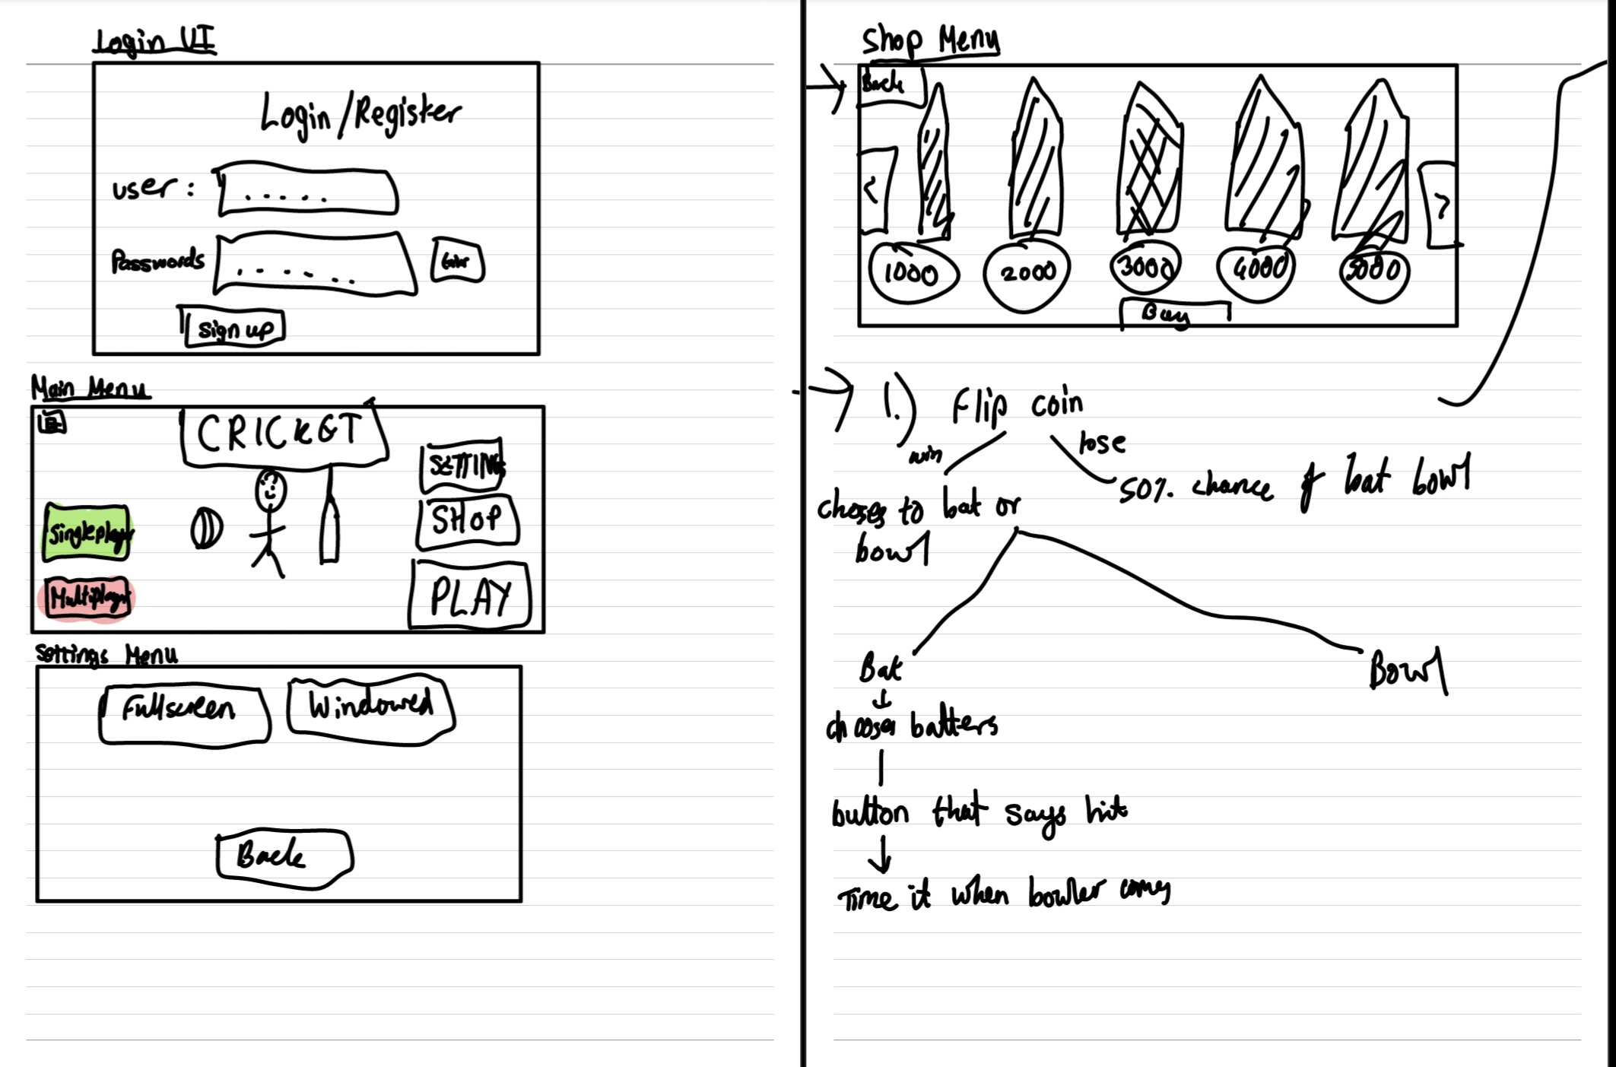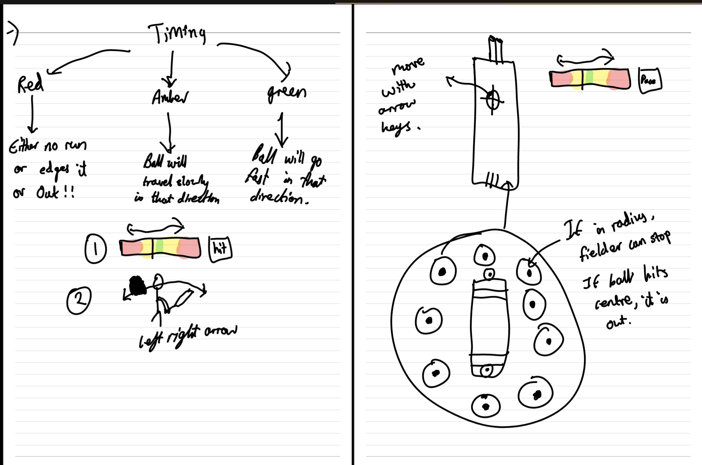

## Core Objectives/

Below, I will have my core objectives listed so that I can make sure that my project is successful. These points will be required to call my project complete.

1. The project will have a menu where they can login or create an account to save their data and save their progress for future statistics to be shown.
   1. When the program opens, there should be a pop-up menu showing the user to login or create an account. There can also be a continue as guest option although their progress will not be saved.
      1. If the user chooses to log in button, a menu will prompt them to enter their username and password for authentication.
         1. This will then be crosschecked by a login table containing all the logins in a database. SQL queries will be executed to confirm that the entered credentials are correct.
         2. Passwords will be hashed using SHA-256 before it is stored in the User table to prevent security flaws.
         3. SQL commands will be executed from the game code which will allow the user details to be retrieved from the table for looking at game statistics.
      2. If they are registering, there will be a menu asking the user to input their username once and their password twice
         1. The username will then be checked if it already exists in the login table in the database (using an SQL query) and if it does, the user will be asked to redo the registration, showing up with an error that says, “Username already exists.”
         2. If the username does not already exist in the login table, then it will store the username and password in it in the database, and the registration will be complete, successfully registering the user (using the INSERT SQL command).
   2. The user will be able to choose if they are a beginner, or familiar with the game.
      1. This is done by the user selecting two buttons, one saying, “beginner” and one saying, “familiar with the game”.
      2. If no options are selected, an error will show up telling the user, “Please pick an option.”.
   3. Having an account will allow the user to store their progress and save the number of wins they have, runs scored and wickets taken.
      1. This will be saved in a table called player information in the database where it can be accessed from any computer if they have their login.
         1. The database will be stored in a client server model where it allows the user to access from anywhere
      2. This can be accessed in the profile menu in the main loading screen.
2. Once the user has logged in, there will be a menu that shows up. It should be a hub to access to all the menus that contain the buttons:
   1. There will be a settings button that takes the user to a settings menu.
   2. There will be a button that will have access to a shop. This will direct them to a menu that shows the different items they can buy.
   3. There should be a play button that takes the user to a menu showing whether they want to play single player.
   4. There will be a leaderboard button where it will take the user to a menu where it shows their score in comparison to others
   5. There will be a profile button that takes the user to a menu where they can access their statistics and game history.
   6. There will be a tutorial button to walk the user through the game, and this will direct the user to the tutorial game.
   7. There will be a daily challenge menu which will allow the user to achieve various difficult tasks to get more coins
      1. This daily challenge menu will be randomly selected per day from a list of challenges from a JSON file.
3. When entering the single player game mode, there will be various options for the user to pick starting with the game type
   1. There will be a slider asking the user how many overs they would like to play. This is to suit the needs of a person who has no time to play or someone who has all the time to play.
      1. This will then direct the user whether they would like to bat, bowl or both.
      2. Then there will be a play button to start the game.
   2. The user will then be taken to the loading screen where they game will be generated. This will load the game scene.
      1. At the start of the game, there will be a coin toss which allows the user to pick heads or tails
         1. After they pick heads or tails, there will be a randomly generated result picking heads or tails
         2. If the user’s choice matches the randomly generated result, then they get to choose if they bat or bowl first.
         3. If the user’s choice does not match the randomly generated result, then there will be a randomly generated result whether they bat or bowl first.
   3. If the user Quits the game whilst a game is in progress, the game should store the stats of the game in a JSON file so when they renter the game, it will continue from where they left off.
4. If the user chooses to bat, they will get a choice of 11 batters to pick from, and each one has different skills.
   1. The user will pick two batters and then the game will begin.
   2. The fielders will be set into default position by the command.
   3. The bowler will start to bowl, and there will be a timing bar which is designed to help the user time the ball properly. This bar will have a slider that traverses the bar, and the player must press a button/key at the right moment, with the aim to hit the green of the bar. This will allow for best timing, and it is easy to learn.
      1. If the user times it into the green zone, maximum power will be applied to the ball, and the ball will travel quicker when hit by the bat.
      2. If the user times it into the yellow zone, power will be at its minimum and the ball will travel slower when hit by the bat
      3. If the user times it into the red zone, the ball will miss the bat and then if it hits the wickets the ball is given out.
   4. After the user has timed the ball properly, as the ball comes there will be a box that the user can control the direction of. Depending on which direction the box is in, is where the batter will hit the ball. This is so that the user can choose where to place the ball.
      1. This box has no correlation to the timing bar. If the batsman times it poorly but the box is placed on the ball, then the bat will still hit the ball
      2. If the batsman times it well but the box is not placed in the direction of the ball, then the bat will miss the ball the user has a chance of being out if it hits the wicket or the batsman edges the ball into the hands of a fielder.
   5. Once the ball connects with the bat and the ball goes in the direction of the box, there will be a function that calculates the runs that are achieved by the batsman. I will use Dijkstra's algorithm to determine the path of the ball and calculate the amount of time it takes for the fielder to collect the ball. Depending on the amount of time it takes, runs will be allocated accordingly.
   6. If the batsman does nothing, then the ball will be called “dead”, and it will be rebowled with no consequences. However, if done three times, the user loses a wicket. This is to ensure that no unfair play happens, and everything is kept nice and enjoyable.
   7. Every run taken must be stored and saved in the server so the player can see their statistics later in the profile menu. Data like the number of runs scored, balls faced, dismissals, boundaries scored, the strike rate and the shot accuracy as a percentage.
   8. The ball should follow a realistic path based on the impact of the bat
   9. If the batsman hits the ball and a fielder catches it without it touching the ground, the batsman is out.
   10. If the batsman misses the ball and it hits the wicket, it is out.
   11. When the batsman hits the ball, there should be a trail so the ball can be followed by the user.
5. If the user chooses to bowl, then they have an option of four bowlers: Pace, off spin, leg spin, inswing and outswing
   1. For each bowler, there will be a Topdown pitch being shown. Then there will be a target. The user will move the target to where they want to bowl and then they will have an accuracy bar with a slider that allows them to decide how accurate their ball will be.
   2. For each bowler the accuracy bar will do different things
      1. If the user times it into the green zone, maximum power will be applied to the ball, and it will be more accurate
      2. If the user times it into the yellow zone, power will be at its minimum and the ball will travel slower as well as a little less accurate
      3. If the user times it into the red zone, the ball will be very inaccurate from their chosen target and the ball will travel even slower.
      4. If the user bowls outside of the wide lines, it will be called a wide ball, and the bowler must rebowl the ball and a run will be awarded to the batting team
      5. After every ball, the details of the ball must be saved into a table with the bowling statistics. This will allow the player to view their statistics in the profile menu. This will be used to calculate economy rate, average, number of wickets and number of balls bowled.
      6. The ball should follow parabolic motion.
      7. The ball should have a tracking feature when the ball is hit so that the user can easily follow the ball.
6. The user will have the ability to move the field if they are bowling by clicking on a mini-map and moving the dots around the field. Each dot on the minimap will correspond with a fielder on the pitch.
   1. Each fielder should have a radius where they will be able to stop the ball in.
   2. If the ball hits the centre of this radius, then it should be a catch, and the batsman should be out.
   3. Once the fielder picks the ball up, they should throw it back into the bowler.
   4. Using Dijkstra's path algorithm, it will calculate the shortest distance from the fielder to the bowler and then will calculate the runs based on that distance.
7. If the player chooses the multiplayer button, then it should take the user to a menu that shows all the multiplayer options:
   1. There will be a label that shows the number of active players
   2. There will be a dropdown menu showing the open lobbies needing a player which the user will be able to join by pressing the join button next to the menu
   3. There will be a button that says create lobby and when they press the button it will ask them for the game type and then create the lobby where other players can view this in the dropdown menu and join the match.
   4. After the game has started the user who hosted the match will flip the coin and the other user will call heads or tails to decide if they bat or bowl
      1. If they win the toss, they can decide if they bat or bowl but if they lose then the other user gets to decide.
   5. When the user gets ready to bat, they will wait for the user to decide the ball they want to bowl and then after it will play just like in single player
   6. The user will have 10 seconds to decide the type of ball that they want to bowl before the timer runs out and then it will be randomly decided for them.
      1. If the user does not wish to bowl, there will be an “auto-bowl” function where there will be an algorithm that decides the type of ball for them.
   7. The user will be able to change the field just like in single player but will only have 10 seconds to do so. This means that the user will only get 10 seconds to set the field and bowl a ball
      1. This timer does not apply to the first ball of the match
8. If the user enters the settings menu there will be an option to:
   1. Turn sounds on or off using a toggle
   2. Fullscreen or windowed mode
   3. Change in the font size
9. Shop
   1. There will be a currency system where every 10 runs scored is one coin. Using this, the number of coins per user will be saved in a JSON file
   2. The shop menu will have lots of items that have a price next to them. To store this, I will use a dictionary to have the name of the item corresponding to its price.
   3. Items should be locked by default and then unlocked after the user has enough coins to buy them and when the user has spent their coins to buy the item.
   4. Players should be able to equip their newly unlocked items in the menu, and this should apply to a game.
   5. Once an item is bought, there should be a clear visual change to show the item has already been bought so the user will not buy it again.
   6. If the user cannot afford to buy the items, then it should show up with a pop-up menu saying that the user cannot afford it. This will then not buy the item and redirect them to the shop.
10. There will be a tutorial system where the user can learn the game slowly and then understand the game more.
    1. The game will introduce the user to key game mechanics like the:
       1. Coin toss – It should explain the pros and cons of picking bowling or batting first
       2. Batting – It should tell them the batting mechanics from the aim slider and the timing bar.
       3. Bowling – It should explain where the bowler can and cannot bowl and introduce them to the timing bar.
       4. Fielding – It should introduce where and how to change the field. This should help the user get some game sense.
11. When the user goes into the leaderboard menu, there will be a leaderboard displaying all the top scores.
    1. This will be taken from the profile table where all the stats are held using an SQL query.
    2. There will be different leaderboards such as most wins, most runs scored, highest win ratio
12. When the user presses the profile button, it will take the user to a profile menu where the following data is displayed:
    1. There will be a statistics menu which shows all the batting and bowling statistics available to the user.
       1. The batting data will be taken from the batting table in the database and then will perform several calculations to show the following:
          1. Batting Average: This is the total runs the user has scored divided by the number of times they have been dismissed.
          2. Strike Rate: The number of runs scored divided by the balls faced, showing how quickly a batsman scores.
          3. Highest Score: The user’s highest score in a match
          4. Number of centuries: The number of times the player’s score is greater than or equal to 100
          5. Number of half-centuries: The number of times the player’s score is greater than or equal to 50
       2. The bowling data will be taken from the bowling table in the database and then will perform several calculations to show the following:
          1. Number of wickets: the number of wickets taken
          2. Bowling average: the average runs conceded per wicket
          3. Overs bowled: the number of overs bowled
          4. Economy rate: the total number of runs conceded divided by the number of overs bowled.
    2. There will also be a button to reset the statistics which will use the DELETE SQL query to delete the data from the batting and bowling tables.
    3. There will also be an inventory button to show the items that the player has, and they can then wear the items in this menu which will then be applied to the next match.

## Extension Objectives/

These are objectives that I will add in the future, and they are not fundamental to the game, but they are features that could make the game much better and improve quality of life.

1. There should be in the settings menu two buttons asking the user whether they want complex controls or simple controls.
   1. If the user chooses simple controls, then the user will be greeted with the default controls they are used to.
   2. If the user chooses advanced controls, then the user can decide whether they want to play a ground shot or a lofted shot. This makes the batting experience more complex and customisable.
2. I will create a player skill tree
   1. There will be a tree of special power boosts, and they can be unlocked with coins
   2. This will then unlock more power boosts in a tree like fashion. This information will be stored in a player table which will be connected to the user table in the database
3. There will be a simulate match button where if the user does not want to bowl, there will be a mathematical calculation which estimates the amount of runs the user would concede.
   1. This will include how many overs they want to simulate and there will be a slider for the user to input how many overs they would like to stimulate.
4. There should be different pitches available to the user to give the user more batting power or more bowling power.
   1. This will be made using pictures of the pitch, which they can click on to select the pitch the user would like to use.
   2. If the user does not pick it will be chosen randomly using the Random function.

## Entity Relationship Diagram/

The diagram below shows all the different tables I will be using in my database and it shows how they are related to each other. This diagram also shows what variable belongs to which table as well as the data type. It also shows whether it is the primary key or the foreign key. The variables in bold are the primary keys and the underlined ones are the foreign keys.

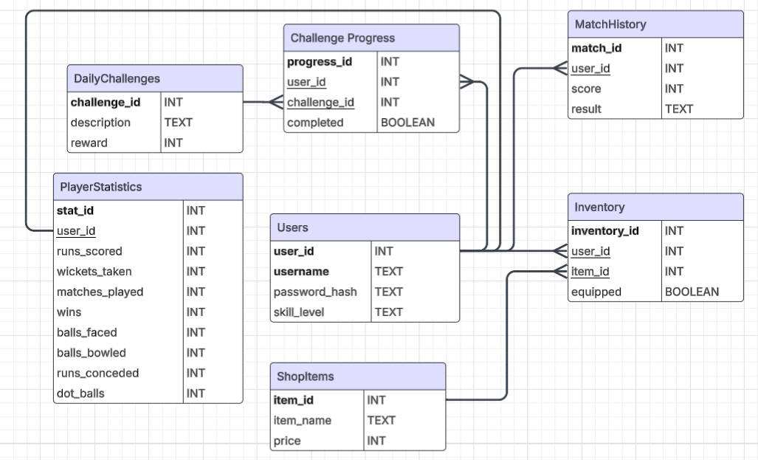

## Data Volume/

* Each match will be stored in a database which will contain the score and if they have won or lost.
  + There is currently no limit to this, however the amount of data that would be inputted will increase proportionally to the matches played.
  + I might have to add a feature where it deletes the match history if the user has more than 10 to ensure data efficiency.
* Each User should have a unique username and User_ID which will be mapped to a user.
  + There is no limit on how many users that can be stored as they typically do not take up much data and are very simple to add.
* The database will store all the statistics in the database
  + Each user gets one playerStats where all the batting and bowling statistics are held.
  + This means that whenever a match is done, the number of runs is added to the statistics instead of creating a new record of it.
* Each challenge will be stored in the database
  + There is no limit to the number of challenges the user can attempt.
* The game will save the user’s current save data in a JSON file when the program closes
  + It makes sure that the game saves the current game if they haven’t finished.

## Data Source and Destination

Will do when im done coding.

## Potential Solutions/

|  |  |  |
| --- | --- | --- |
| **Potential Solution** | **Positive** | **Negative** |
| Using Windows Forms in C# | 1. I have experience using C# in windows forms and have made applications in it.  2. It has many libraries that I can access and use.  3. It is very simple to code and debug.  4. The drag and drop creation of menu allows for quick creation. This means that the  5. It is free to use so I do not have to pay for the software. | 1. It is very difficult for physics simulation and sprite animation so I will have to manually create the physics engine myself.  2. It is very good for handling menu systems or simple turn-based games but not for real time graphics rendering. |
| Using Unity in C# | 1. Unity provides a powerful rendering and physics engine straight away. In comparison to other game engines, it is much easier to learn.  2. Unity uses C#, and it is very good for object-oriented programming, and I am much more familiar to it than python.  3. It is free to use so I do not have to pay for the software.  4. It has a GUI (graphical user interface) so the user is more immersed into the cricket game. They will also see a visual response when they bowl. | 1. I will need to manage the files carefully as due to the number of scripts, it can get very complicated and disorganised.  2. It can take up a lot of RAM which some users may not have a lot of.  3. Unity can be very processing intensive. |
| Using Unreal Engine in C++ | 1. It can produce realistic visuals, which could make for a very aesthetically pleasing cricket game.  2. It is very powerful and efficient. | C++ is a very complex language and it takes a lot of time to learn. Additionally, the game engine is significantly harder to learn than Unity, so it makes it very time consuming to just set up the game. Instead, I could spend time implementing features. |
| Console Application in C# | 1. Console applications are simple and easy for straightforward interactions  2. Console applications have a wide range of libraries that can be used and have frameworks that can elevate a game. | 1. Console applications lack a GUI (graphical user interface) which limits the users’ interactions for bowling. It limits the immersion as they cannot see the game they are playing only text outputs.  2. I would have to program my own physics engine and then I would have to program the mechanics which would take too long in the time frame I have. |

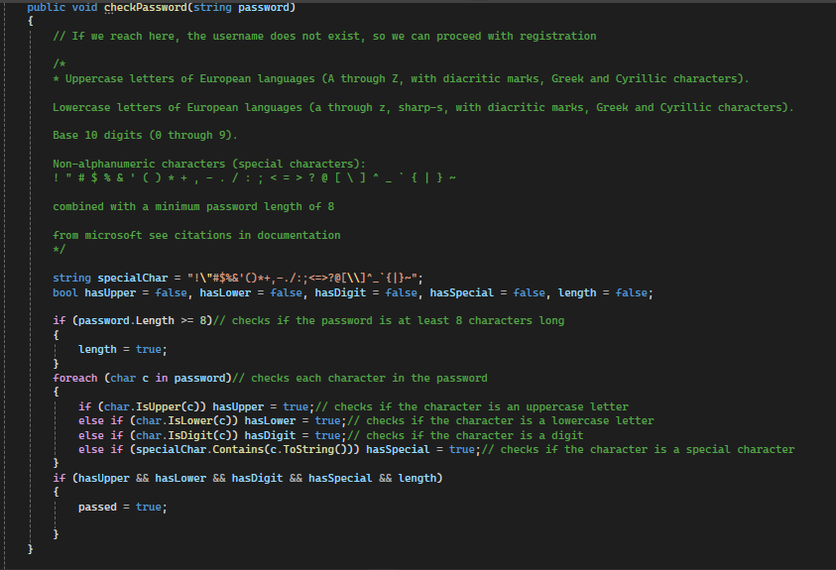

## Chosen Solution/

The solution I have chosen is to create this game in Unity and will code in C#. I will create my database in DB browser with SQLite.

# Design

## Description

## IPSO Chart

|  |  |  |  |
| --- | --- | --- | --- |
| **Input** | **Process** | **Storage** | **Output** |
| User Login Details  -Username  -Password |  |  |  |
| User Registration Details  -Username  -Password |  |  |  |
| User presses singleplayer, chooses the overs that should be played and finishes playing the game |  |  |  |
| During the game the user presses the space when bowling. |  |  |  |
|  |  |  |  |
|  |  |  |  |
|  |  |  |  |

## Overall System Design

## Navigation Structure

## Page Navigation

## Design Data Dictionary

## File Organisation and Processing

## Hierarchy Chart

## System Flowchart

## Data Validation

## Sample of planned SQL Queries

## Data Definition Language

## User Interface Design

## Important Algorithms and Pseudocode

## Security and Integrity of Data